VLOOKUP (Vertical Lookup) is a function that searches for a certain value in a column to return a corresponding piece of information
VALUE is a function that converts a text string that represents a number to a numerical value
Absolute reference is a reference that is locked so that rows and columns won’t change when copied
MATCH is function used to locate the position of a specific lookup value
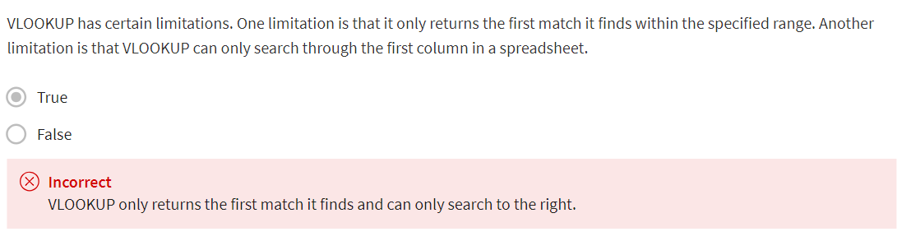
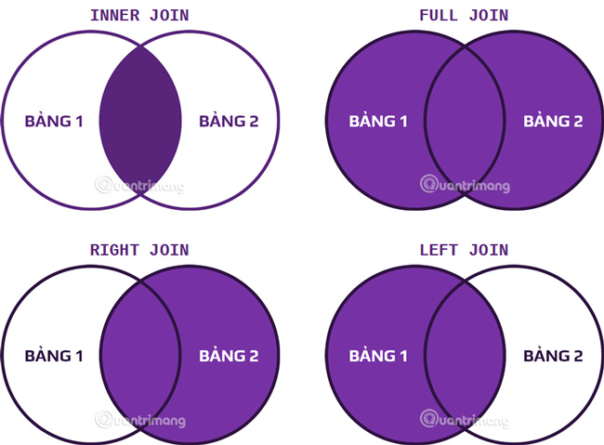
JOIN is a SQL clause that is used to combine rows from two or more tables based on a related column
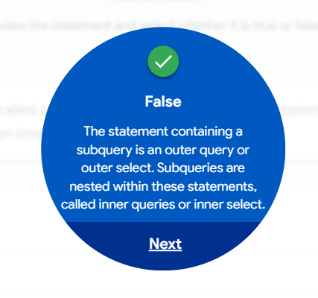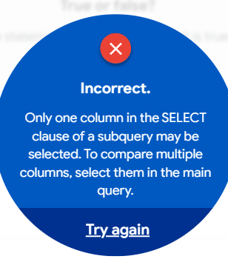
Glossary terms from module 3
Terms and definitions for Course 5, Module 3
Absolute reference: A reference within a function that is locked so that rows and columns won’t change if the function is copied
Aggregation: The process of collecting or gathering many separate pieces into a whole
Aliasing: Temporarily naming a table or column in a query to make it easier to read and write
COUNT DISTINCT: A SQL function that only returns the distinct values in a specified range
Data aggregation: The process of gathering data from multiple sources and combining it into a single, summarized collection
INNER JOIN : A SQL function that returns records with matching values in both tables
JOIN: A SQL function that is used to combine rows from two or more tables based on a related column
LEFT JOIN: A SQL function that will return all the records from the left table and only the matching records from the right table
LIMIT: A SQL clause that specifies the maximum number of records returned in a query
MATCH: A spreadsheet function used to locate the position of a specific lookup value
OUTER JOIN: A SQL function that combines RIGHT and LEFT JOIN to return all matching records in both tables
RIGHT JOIN: A SQL function that will return all records from the right table and only the matching records from the left.
Subquery: A SQL query that is nested inside a larger query
VALUE: A spreadsheet function that converts a text string that represents a number to a numeric value
